STOC 2005
Local Information

STOC conference hotel:

Marriott Hunt Valley Inn
245 Shawan Road
Hunt Valley, MD 21030, USA
Phone: +1-410-785-7000
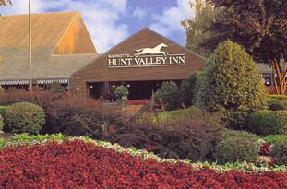

Facilities and services: On-site restaurant, room service, coffee shop, cocktail lounge, laundry valet, concierge services, gift shop/newsstand, full business center, safe deposit.

Guest room amenities: Speaker phone, voice mail, high-speed internet access ($10 for each day to use hotel-wide WLAN, but a free conference WLAN will be available in a limited area), TV with remote control, in-room movies, newspaper delivered (Mon-Fri), refrigerator available, complimentary in-room coffee, iron and ironing board, hairdryer, bathrobe, cribs available.

Sports and recreation: Indoor and outdoor pool, fitness center with exercise room , whirlpool, sauna, massage therapist, tennis courts. Golf, squash, and jogging and biking trails nearby.

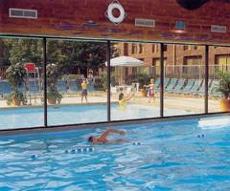
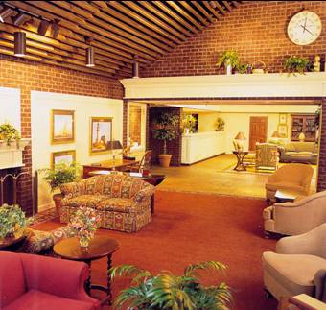
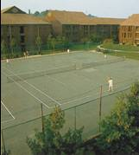

Travel

Traveling by airplane:
- The closest airport Baltimore/Washington International Airport (BWI) is 30.6 miles away from the hotel (Baltimore Marriott Hunt Valley Inn).
- Ronald Reagan Washington National Airport (DCA) is 62.7 miles away from the hotel (Baltimore Marriott Hunt Valley Inn).
- Washington Dulles International Airport (IAD) is 79 miles away from the hotel (Baltimore Marriott Hunt Valley Inn).
- AMTRAK stations: Baltimore, MD - Penn Station (BAL) and Baltimore, MD - BWI Airport Rail Station (BWI).
- Maryland Transit Administration (MTA) provides comprehensive information about services of local and commuter buses, metro subway, etc.
From BWI, it is recommended to travel by taxi (around $55.-) or shuttle (around $35.-). Reservations can be made at www.theairportshuttle.com and at www.supershuttle.com. A much cheaper ($1.35 one way) but more time-consuming way of reaching the hotel is to use the light rail system. The light rail system has a stop at BWI and a stop within walking distance of the hotel (see the map on the next page). Unfortunately, a part of the light rail track is currently under construction (north of North Avenue) so that a part of the trip has to be done in a shuttle bus. For more information, please visit www.mtamaryland.com.

From the other airports, either a shuttle (see the links above) or a rental car from AVIS may be used. A rental car from AVIS is convenient because AVIS has a branch within walking distance of the hotel (see the map on the next page).

Traveling by car:

Once on I83, leave the I83 at exit 20A. The conference hotel is located at the right side. It has plenty of parking spaces available for guests and conference attendees.

Local Map
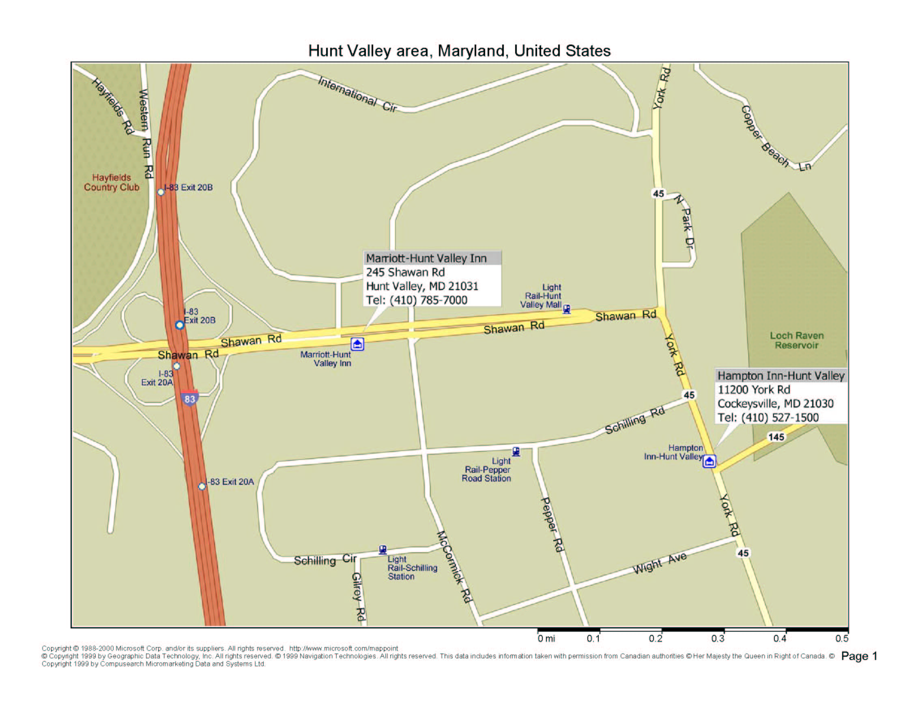

Shopping Mall
AVIS
Bus 8

STOC 05

alternative hotel

From Shopping Mall to STOC Hotel:
Follow Shawan Road till McCormick Road (where pedestrian way on Shawan Road ends). Go south on McCormick Road and then right across a parking place to get to the hotel.

From STOC Hotel to Baltimore:
One may either use a taxi from the hotel, bus line 8 (stops at Wal-Mart at the shopping mall), or the light rail system. The Baltimore Inner Harbor has many attractions including the Baltimore Maritime Museum, the Maryland Science Center, and the National Aquarium.

Transportation

Light Rail:

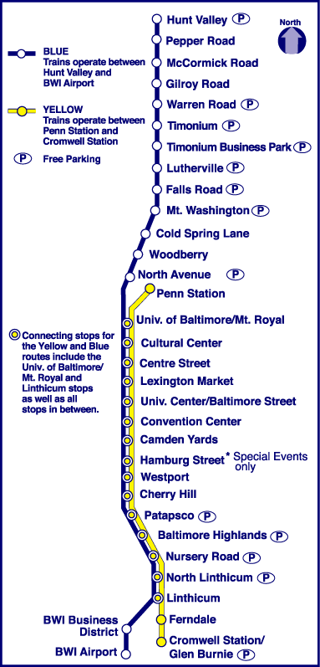
Bus line 8:

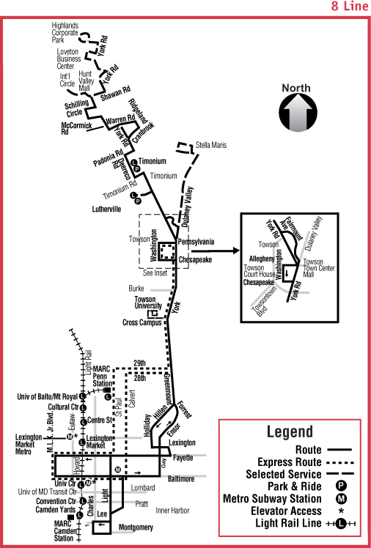

Global maps



